**SURVEY ON IOT ENABLED MOTION DETECTOR CAMERA IN SMART INDUSTRY**

# A PROJECT REPORT

## Submitted by

**ANUPAM KUMAR RAO**

**(Reg.No.: 19MCR004)**

**RISHI RAJ**

**(Reg.No.: 19MCR020)**

**VISHAL KUMAR**

**(Reg.No.: 19MCR028)**

***in partial fulfilment of the requirements for the award of the degree of***

**MASTER OF COMPUTER APPLICATIONS**

# DEPARTMENT OF COMPUTER APPLICATIONS

**KONGU ENGINEERING COLLEGE**

## (Autonomous)

**PERUNDURAI, ERODE – 638060**

**NOVEMBER 2021**

ii

# DEPARTMENT OF COMPUTER APPLICATIONS

# KONGU ENGINEERING COLLEGE

## (Autonomous)

## PERUNDURAI, ERODE – 638060

**NOVEMBER 2021**

**BONAFIDE CERTIFICATE**

This is to certify that the project report entitled **“SURVEY ON IOT ENABLED MOTION DETECTOR CAMERA IN SMART INDUSTRY”** is the bonafide record of project work done by **ANUPAM KUMAR RAO (Reg.No.:19MCR004), RISHI RAJ (Reg.No.:19MCR020**)**, VISHAL KUMAR (Reg.No.:19MCR028)** in partial fulfilment for the award of Degree of Master of Computer Applications of Anna University, Chennai during the academic year 2021-2022.

## SUPERVISOR HEAD OF THE DEPARTMENT

**(Signature with seal)**

Date

Submitted for the mini project viva-voce examination held on

## INTERNAL EXAMINER EXTERNAL EXAMINER

iii

**DECLARATION**

We affirm that the project entitled **“SURVEY ON IOT ENABLED MOTION DETECTOR CAMERA IN SMART INDUSTRY”** being submitted in partial fulfilment of the requirements for the award of Master of Computer Applications is the original work carried out by us. It has not formed part of any other project report or dissertation on the basis of which a degree or award was conferred on an earlier occasion on this or any other candidate.

**Date:**

# ANUPAM KUMAR RAO

# (Reg.No. : 19MCR004)

**RISHI RAJ**

**(Reg.No. : 19MCR020)**

**VISHAL KUMAR**

**(Reg.No. : 19MCR028)**

I certify that the declaration made by the above candidate is true to the best of my knowledge.

**Date:** Name & Signature of the Supervisor

## [Dr.D.SIVABALASELVAMANI]

iv

**Abstract**

Security issues are discussed nowadays in all areas of our daily life. Monitoring of objects as well as peoples are needed at every place and every time. The problem can be seen only in a large number of financial costs for hardware devices and needed space for video recording. Detection of human activity is a set of techniques that can be used in a wide range of cameras, including medical health care and smart home. With the advanced development and commercialization of IoT-enabled devices and crucial demands, human activity measuring the efficient states or health of individuals in a smart home-based environment has been a highly dynamic and important topic in recent years since its related to human life.

In motion detector camera system is capable of identifying humans by using the motion detector sensor has been developed. Motion sensor is used to identify the objects. This technique is used for improving the camera system and enhance the definition of clusters in each region. we incorporate advantages of both technologies (motion sensing and data compression) to build up a smart surveillance system. PIR based security system which saves the power consumption and Data compression technique using winzip which saves memory space of the recording system has been proposed. After detection of motion by PIR sensor the webcam will be turned on. Software was developed and installed in the computer to capture and record the video when the webcam gets turned ON. Once the person moves out of detection range of the sensor, the webcam gets turn OFF. Motion sensor surveillance camera with data compression technique is a device which is useful to overcome the wastage of power and storage space. In this we are using Motion sensor for detecting real time motion due to which the device is only on when there is motion resulting in power saving.

The project is simply presented the concept of developing motion sensor-based camera. Some of the other features like motion alarm and security SMS are also introduced for increasing the security aspects of the device. This system is useful in the field of Industrial, Commercial, Defence and Domestic to make data storage and security cost efficient.

v

# ACKNOWLEDGEMENT

We thank our Correspondent **Thiru.P.SACHITHANANDAN, B.Sc.** and our Principal **Dr.V.BALUSAMY M.Tech., Ph.D.** Kongu Engineering College, Perundurai for providing us with the facilities offered.

We convey our heartfelt thanks to our Head of the Department **Dr.R.THAMILSELVAN MCA., M.E., Ph.D.** Department of Computer Applications, Kongu Engineering College for his perfect guidance and support that made this work to be completed successfully.

We also like to express our gratitude and sincere thanks to our project guide **Dr.D.SIVABALASELVAMANI MCA., Ph.D.** Associate Professor, Department of Computer Applications, Kongu Engineering College, for giving his valuable guidance and suggestions , which helped us in successful completion of the project.

We also like to express our gratitude and sincere thanks to our project coordinator **Dr.T.M.SARVANAN, MCA., M.Phil., Ph.D.** Associate Professor, Department of Computer Applications, Kongu Engineering College, who have motivated us in all aspects for completing the project in scheduled time.

We our great deal of gratitude to our parents for helping us to overwhelm in all proceedings. We bow our heart and head with heartfelt thanks to all those who thought us their warm service to succeed and achieve our work.

vi

|  |  |  |
| --- | --- | --- |
| **TABLE OF CONTENTS** | | |
| **CHAPTER No.** | **TITLE** | **PAGE No.** |
| **1.**  **2.**  **3.**  **4.**  **5.** | **ABSTRACT**  **LIST OF FIGURES**  **LIST OF ABBREVATIONS**  **INTRODUCTION**  1.1 Objective of Project  1.2 Overview of Project  1.2.1 Application Layer  1.2.2 Network Layer  1.2.3 Preception Layer  1.2.4 Web Camera  1.2.5 Decision Making Algorithm  1.2.6 Storing  1.3 Motion Detector Camera in different sector  1.3.1 Defence Sector  1.3.2 Commercial Sector  1.3.3 Domestic Sector  1.3.4 Industrial Sector  **LITERATURE RIVIEW**  **PROPOSED WORK**  3.1 Introduction  3.2 Creating Environment for Camera  3.3 Work Flow of Camera  3.4 Sensors Used  3.4.1 Arduino Uno R3 board  3.4.2 PIR Motion sensor  3.4.3 WEB Camera  3.5 Result Assessment  **METHOD USED**  4.1 Motion and Object Detection  4.2 Object Classification  4.3 Object Tracking  4.4 Behavioral Analysis  4.5 Data Fusion  4.6 Network Switch  4.7 Storage of Data  **CONCLUSION AND FUTURE WORK**  5.1 Conclusion  5.2 Future Work  **APPENDIX**  **APPENDIX 1 - SMPLE CODING**  1.1 Arduino Code  1.2 Visual Studio Code  **APPENDIX 2 - SCREENSHOTS**  **REFERANCES** | iv  viii  ix  1  1  2  2  2  3  3  3  3  4  4  5  5  5  6    vii  9  9  9  10  11  11  11  11  11  13  14  14  14  14  14  15  15  16  16  16  17  17  17  18  22  25 |

viii

# LIST OF FIGURES

|  |  |  |
| --- | --- | --- |
| FIGURE No. | TITLE | PAGE No. |
| 1 | The Layers in IOT | 2 |
| 2 | Architecture of a Motion Detection Camera | 3 |
| 3 | Diagram of motion sensor connection | 4 |
| 4 | FDPA algorithm process flow chart | 10 |
| 5 | Click the photos in motion detection | 12 |
| 6  7  8  9  10  11  12  13 | Saving photos in Image folder  Case study scenario representation  Connecting Arduino Board to computer  Display of motion detector camera  Camera in activation mode  Human and motion detected  Clicking photos after motion detection  Picture saved in assigned Image folder | 12  13  22  22  23  23  24  24 |

ix

|  |  |  |
| --- | --- | --- |
| **LIST OF ABBREVATIONS** | | |
| IOT  CCTV  TCP  IP  OSI  PIR  DIY  USB  SD  VCC  GND  LED  VB  PWM  ICSP  DBMS  MAC  HAR | Internet Of Things  Closed Circuit Television  Transmission Control Protocol  Internet Protocol  Open System Interconnection  Passive Infrared Sensor  Do It Yourself  Universal Serial Bus  Secure Digital  Voltage Common Collector  Ground  Light Emitting Diode  Visual Basic  Pulse Width Modulation  In Circuit Serial Programming  Data Base Management System  Media Access Control  Human Activity Recognition |

1

**CHAPTER 1**

**INTRODUCTION**

**1.1 OBJECTIVE OF PROJECT:**

CCTV camera is also known as third eye. The word camera comes from ‘camera obscura’ which means “dark chamber” that was first invented in 1942 by German engineer, ‘Walter Bruch’. Now a days it is one of the major part of our security that record our all the activity while they are performing their tasks on a 24/7 basis and producing huge amount of data which is the concern of storage. The most apparent work of camera is to record all the live activity but now they are not operated automatically.

The goal of this project is to detect Human Activity Recognition (HAR) plays a significant role in an extensive range of real-time applications which including a smart city, smart grid, smart home, sports, health care and so on. Typically, smart mobile devices widely used for recognize human activity with the help of smart camera. A smart home can be referred as, a house which is equipped a convenient set up such as sensors, middleware, interfaces and other enabled devices that can be automatically connect and remotely controlled anywhere with a help of internet connection using an enabled network device or mobile phone. The interconnected smart home devices through internet, allows the human to control the enabled functions remotely which including lighting, security, temperature, refrigerator, TV, and so on. It will be accomplished based on the requirements of the residents which, including their convenience, entrainment, luxury, and security.

A key point in the progress of smart camera is the detection of day-to-day activities or any other specific concern of its residents. This recognition activities could be more benefitable to our quality of lives, especially elderly. Automatic call to fire station or police station in case of any emergency, allow users to reduce electricity use, alert the user if any motion (abnormal or suspicious) in the home when they are out of the home, elderly fall detection, and so on. As a result, installing a smart camera provides a user can control the environment rather than the controlling lighting also.

# 2

**1.2 OVERVIEW OF PROJECT**

Today, innovation is presented in different fields like aviation, inserted, homes, vehicles and society. IOT is one of the fields that is fusing this change also. Among the various advancements, this paper will zero in on IOT - Internet of Things. As we realize that IOT is interfacing objects that are equipped for correspondence.

A typical model is having savvy that is utilized for data and energy saving among numerous different sectors. This camera can detect the motion after that it will be start functioning and store the data of real-time only.

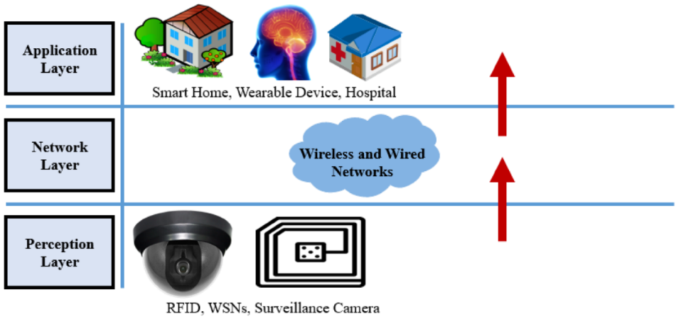

## Figure 1: The Layers in IOT

**1.2.1 Application Layer:**

Application Layer specifies the shared communications protocols and interface methods used by hosts in a communications network. And it is specified in both the Internet Protocol Suite (TCP/IP) and the OSI model.

**1.2.2 Network Layer:**

We are using here Network Layer forLogical connection setup, data forwarding, routing and delivery error reporting are the network layer's primary responsibilities.

3

**1.2.3 Perception Layer:**

Perception layer is the physical layer, which has sensors for sensing and gathering information about the environment.

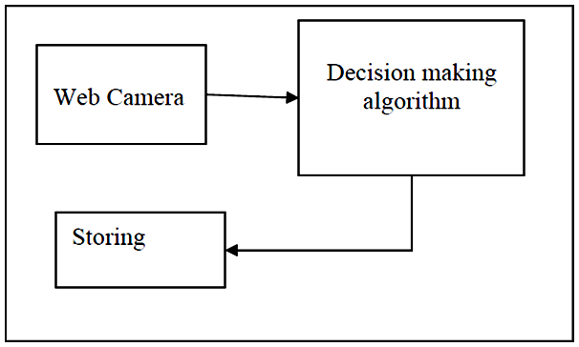

Figure 2: The Architecture of a Motion Detection Camera

**1.2.4 Web Camera:**

Here we can use either integrated (laptop/mobile) camera or any external camera integrated with PIR motion sensor. When any motion detected on that time our camera will automatically activate.

**1.2.5 Decision making algorithm:**

In this scenario algorithm is going to check is it human or not. If human is detected on that time it will show on display human is detected.

**1.2.6 Storing:**

After detecting human motion camera clicked the photos and store in located folder. We will make our own DIY version of such devices in this project. The project is based on the Arduino Yun, to which a regular USB webcam and a PIR motion detector will be connected in order to build some amazing applications.

The initial application will be a modernized version of conventional security camera tasks, such as shooting photos when motion is detected. The project will save photos taken with the USB camera to an SD card that will be plugged into the Yun, but that's not all.

4

We also want these photos to be automatically uploaded to a secure location because we live in the Internet of Things era. And that's exactly what we're going to do by simultaneously uploading the photos to assigned folder.

* In Arduino UNO board connect PIR motion sensor
* Pin-4 of Arduino is connected to ‘out’ pin of motion sensor.
* Pin-5v is connected to ‘VCC’ pin of motion sensor.
* GND pin of Arduino is connected to GND pin of motion sensor.

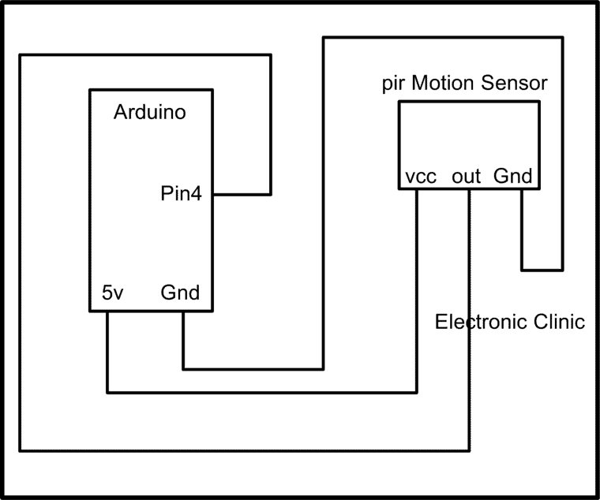

Figure 4: Diagram of motion sensor connection in Arduino uno board

# 1.3 MOTION DETECTOR CAMERA IN DIFFERENT SECTOR

**1.3.1 Motion Detector in Defense:**

A motion detector is a device that detects moving objects, particularly people. Such a device is often made up of different components like Arduino YUN, HC-SR04 sensor, connected with a battery and LED (Light Emitting Diode) to alert the user about motion in a particular area which is crucial for security. A motion detector can be used in the sensors of a burglar alarm that is used to alert the military when it detects the motion of a possible intruder.

1. A motion detector can be used in the
2. sensors of a burglar alarm that is used to alert
3. the military when it detects the motion of a
4. possible intruder.
5. A motion detector can be used in the
6. sensors of a burglar alarm that is used to alert
7. the military when it detects the motion of a
8. possible intruder.
9. A motion detector can be used in the
10. sensors of a burglar alarm that is used to alert
11. the military when it detects the motion of a
12. possible intruder.
13. A motion detector can be used in the
14. sensors of a burglar alarm that is used to alert
15. the military when it detects the motion of a
16. possible intruder.

5

**1.3.2 Motion Detector camera in commercial sector:**

Motion detectors have found wide use in commercial applications; If you’re in the market to buy commercial security cameras, you’ve probably already spent some time reviewing the options available. No matter which cameras you’re looking at, they can be classified into one of three categories of cameras: analog, analog-HD, and IP. Each type of security camera has unique advantages and disadvantages, and they will meet different needs.

Here are the three types of commercial security cameras you should consider:

**1.3.3 Motion Detector camera in domestic sector:**

Motion detectors have found wide use in domestic applications; Motion sensors for homes are manufactured with personal security and convenience in mind, and motion sensors for businesses are designed to protect property as well, just on a larger scale.

* Keep homes and families safe from intrusions.
* Prevent burglary and theft on commercial properties.
* Stop animals from straying into dangerous areas.
* Keep unauthorized personnel from trespassing on restricted grounds

**1.3.4 Motion Detector camera in Industrial sector:**

Motion detectors have found wide use in domestic applications; Industrial camera is a special type of camera that is adapted to work in harsh conditions (high temperatures, pressure, and vibration). They are used to control the production cycle, track units on conveyors, detect ultra-small parts, etc. Therefore, in general, their scope is almost limitless.

6

# CHAPTER 2

# LITERATURE REVIEW

**[2.1]** **Rachida Ait Abdelouahid et al.,** use a characterisation, modelling, implementation, and validation approach to examine the topic of interoperability across connected objects. Indeed, the literature study revealed that IoT architectures lack an interoperability vision and frequently do not leverage technologies that provide a greater level of compatibility. They developed an interoperability architecture for the Internet of Things domain to tackle this problem. This is mostly used to generate specialized architectures, ensure IoT platform interoperability, ensure technical clarity, and maximize productivity.

**[2.2] Internet of Things in embedded system: Chanthaphone Sisavatha et al.,** While researching embedded systems, it came across concerns such as network, environmental protection, and ecology from a system perspective. As we all know, home security is becoming increasingly important as the risk of infiltration grows every day. This design constructs a smart home system based on the internet of things, using the design concept of "Internet of Things close to life and easy to use." The smart house and campus architecture described in this study is based on current modern software and hardware technology, yet it is still influenced by old conceptions. To ensure that the structure being developed, as well as the technology employed, are scalable and have a longer life cycle, smart house design must be forward-looking and carefully focus on current technology advances. This study proposes a system structure that incorporates more modern software and hardware technologies.

**[2.3] Internet of Things in smart homes, presents two IoT-based technologies: Cristina Stolojescu-Crisan et al.,** In the framework of smart homes, presents two IoT-based technologies. To begin, there's qToggle, a multi-home automation platform, and MotionEyeOS, a video surveillance operating system for single-board computers.

7

Home security is a good example of how the Internet of Things may be used to create a low-cost security system for households, as well as the industrial and commercial sectors. ESP8266/ESP8285 chips or Raspberry Pi boards and smart sensors are used in the majority of qToggle devices, whereas Motion Eye uses Raspberry Pi boards. The proposed systems are simple to implement because they do not require a large infrastructure, which is an advantage over other existing systems.

**[2.4]** **Internet of Things evaluation in Smart Industry related works:**  **Abdellah Daissaoui et al.,** proposed an evaluation of IoT in Smart Industry related works. A range of sensors and dedicated networks are used in today's smart building management systems. The basic goal is to keep an eye on the state of certain regions and apply relevant rules to maintain or improve comfort while conserving energy. The Internet of Things is primarily used to provide new options for smart industry management. The large amount of data produced from sensor networks feeds large amount of Data in databases, allowing for in-depth analysis to discover the needs of smart industry operators using IoT. Finally, they recommended using motion sensor data integration and an ecosystem of smart induatry services to dynamically govern the movement of people in smart building areas.

**[2.5]** **The usage of IoT and blockchain technologies in system design and energy efficiency of a smart building:** **Michal Gergus et. al.,** The usage of IoT and blockchain technologies in system design and energy efficiency of a smart building was investigated by the authors. They looked at these technologies to see if they could operate together to provide secure storage and management of data and information linked to building operations, as well as improve iot services. The authors considered that the proposed design may be used in a variety of public and private structures where building efficiency, human safety, and data and information security are all critical.

8

**[2.6] IoT-enabled smart door that can monitor body temperature: HR Yogesh.,** advocated an evaluation of current advances and the availability of smart technology that could help developing countries achieve their needs.The author of this review looked at an IoT-enabled smart door that can monitor body temperature and identify face masks to improve public safety. They developed a Raspberry Pi-based real-time deep learning system to detect face masks, detect temperature, and keep track of the number of persons present at any one time. They confirmed that the gadget performed admirably in terms of temperature measurement and mask identification, with the trained model achieving a 97 percent accuracy.

9

**CHAPTER 3**

**PROPOSED WORK**

**3.1 INTRODUCTION:**

We have simply presented the concept of creating sensor-based camera, in this article this proposal will be used in the future to improve India’s data storage and security make cost-efficient. It is obvious that technological tools and equipment as well as financial support are vital in order to simulate both the smart technology building template and the management system that monitors data and energy consumption in Industry. These facts were a limitation in our research. Therefore, a desirable and reasonable future goal of this research is both the implementation and testing of the management system that monitors and controls the smart building template and the implementation and testing of the management system that concludes the data storage and energy efficiency of an existing Industry and proposes solutions to transform the industry, according to the current legislation, into environmentally friendly.

**3.2 CREATING ENVIRONMENT FOR CAMERA**

Here we are using Visual Basic 10 express edition for making the camera environment. Firstly, creating a new project in VB, in the form using Image Box for showing the live activity of camera, using level boxes for showing the height and width of human. We are creating 2 text boxes for showing motion is detected or not and also showing number of clicked photos. Using one button for click the pictures instantly. The goal of this first application is to snap a picture anytime the PIR motion sensor detects motion. When that happens, save the photo to the Located folder. The code will be divided into two sections to accomplish this. The first is a Visual Basic code script that connects to the located folder then takes a photo through camera and finally upload it into particular located folder. The reason for using VB code for this phase is that uploading files to assigned location from VB code is much easier than through the Arduino program.

10

The Arduino sketch, which will effectively call the Visual Basic code to take images via the Bridge library, will be the second half of the code.

Step 1: Firstly, switch on the camera.

Step 2: Program is going to initialize.

Step 3: Live Video Streaming is going to be start.

Step 4: If motion is detected then image will be captured

Step 5: Again, and again this process is going to be repeated.

**3.3 WORK FLOW OF CAMERA**

This process of the work start by motion detection and if it is then after program will be initializes and live video streaming will be start. If again any motion will detect then camera capture the current frame and send captured image to the person email and send the notification to the user.

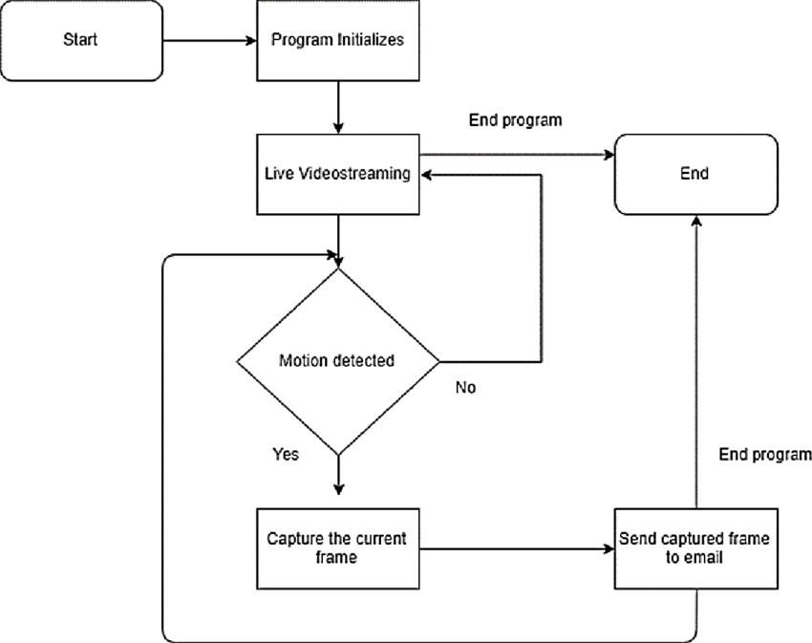

Figure 6: FDPA Algorithm Process Flow

11

**3.4 SENSORS USED**

**3.4.1 Arduino UNO R3 Board:**

Itis a microcontroller board based on the ATmega328P. It has 14 digital input/output pins (of which 6 can be used as PWM outputs), 6 analog inputs, a 16 MHz ceramic resonator (CSTCE16M0V53-R0), a USB connection, a power jack, an ICSP header and a reset button.

**3.4.2 PIR Motion Sensor:**

PIR sensors allow you to sense motion, almost always used to detect whether a human has moved in or out of the sensors range.

**3.4.3 Web Camera:**

Itconnects to a computer and captures either still pictures or motion video, and with the aid of software, can transmit its video on the Internet in real-time.

* + - * Motion Detected.
      * Human is in your Range.
      * Human Detected
      * Height - 162, Width - 162
      * Number of Clicked Pictures – 7

Here motion is detected after that camera and also human is in the frame in within a fraction of second it will automatically click the photos till human is in the camera range. There after photos is going to be upload in assigned folder.

# 3.5 RESULTS ASSESSMENT

After running the code motion sensor by waving your hand in front of it, for example. Soon after, you should notice that the webcam is turned on (for example, if my webcam has a LED that turns on when it is active) and object detection process will automatically start, and if some motion will happen then it will automatically click the the photo and upload it into assigned folder.

12

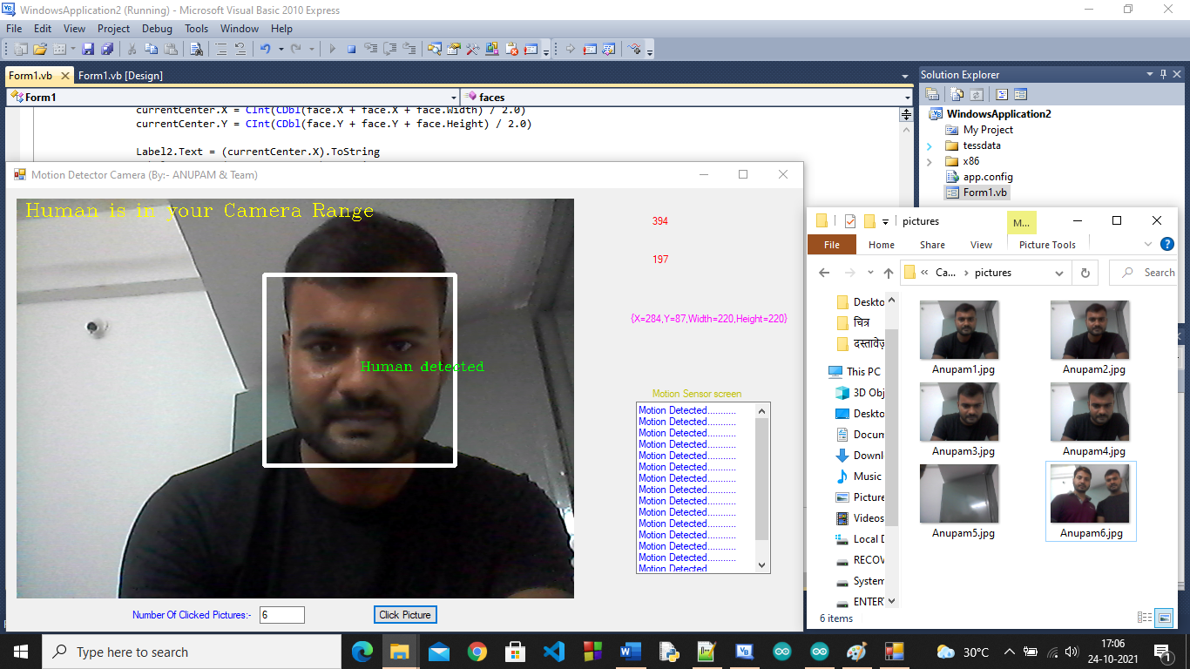

Figure 7: After motion detected it will be click the photos

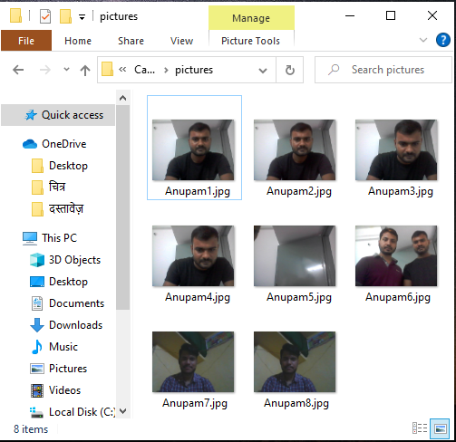

Figure 8: Clicked picture Saved in assigned ‘pictures’ folder

13

# CHAPTER 4

**METHOD USED**

The data is collected from the camera through the sensors. In this case we are using the built- in sensors available in the camera. These sensors in the camera read data about the real-time data at every interval. This raw data is sent to the storage, where for computing takes its role. Arduino Uno is used for the camera automation where the real-time data is stored. There is set for every reading taken from the motion sensor to detect the motion. By default, all the data is directed to the cloud data storage for later use. If the motion in the camera detected, an alert is forwarded to the owner. This alert is routed to the respective motion detected and start the recording of that time only. This camera automation prevents the time storage taken by sending the data over the network for processing and later on there is another time delay in sending the alert to the owner. The camera automation removes these time delay and store real-time data directly to the storage.

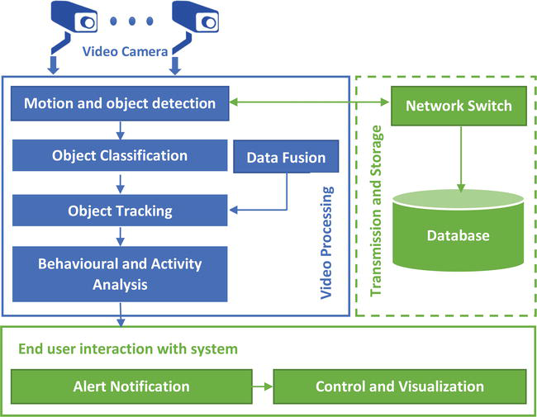

Figure 9: Case Study Scenario Representation

14

**4.1 MOTION AND OBJECT DETECTION:**

Detecting and tracking objects in full-motion video have important applications such as Human monitoring, security, and video surveillance, among many others. Despite its various uses, most people tend to shy away from doing any computer vision work due to its complexity without realizing there are many libraries and packages available which make implementation straightforward.

**4.2 OBJECT CLASSIFICATION:**

Live feed of a camera can be used to identify objects in the physical world. Using the “streaming” mode of ML Kit’s Object Detection & Tracking API, a camera feed can detect objects and use them as input to perform a visual search (a search query that uses an image as input) with your app’s own image classification model.

**4.3 OBJECT TRACKING:**

Object tracking is the process of locating and following one or more objects over time using a camera. It has a variety of uses, including human-computer interaction, security and surveillance, video communication, augmented reality, traffic control, medical imaging, video editing, and even compression our blog post on compression talked about detecting movement from frame to frame.

**4.4 BEHAVIORAL ANALYSIS:**

By adding a second camera, not only more reliable behavior analysis is possible, but it also enables to map the ongoing scene events onto a 3D setting to facilitate further semantic analysis.  The second contribution is the introduction of a 3D reconstruction scheme for scene understanding and generate a fitting skeleton model.

**4.5 DATA FUSION:**

It is the process of integrating multiple data sources to produce more consistent, accurate, and useful information than that provided by any individual data source. Data fusion processes are often categorized as low, intermediate, or high, depending on the processing stage at which fusion takes place.

15

**4.6 NETWORK SWITCH:**

A network switch (also called switching hub, bridging hub, and, by the IEEE, MAC bridge) is networking hardware that connects devices on a computer network by using packet switching to receive and forward data to the destination device.

**4.7 STORAGE OF DATA:**

A database is an organized collection of structured information, or data, typically stored electronically in a computer system. A database is usually controlled by a database management system (DBMS).The data can then be easily accessed, managed, modified, updated, controlled, and organized.

16

# CHAPTER 5

**CONCLUSION AND FUTURE WORK**

**5.1 CONCLUSION**

Nowadays increase in the use of the IOT; there is a huge amount for data to be process in the real time and efficiency. The motion sensor based camera detect the real-time activity and store the data of real-time otherwise it is in standby mode. This technique help us to reduce the storage of huge amount of data and it also makes our storage cost efficient. The motion sensor based cameras service aims to address the issues of storage and it also reduce the data generated from previous CCTV camera. In the Survey, it is found that Smart buildings consume over 40% of the total energy consumption in the U.S. With these, data and energy consumption is recognized as an international goal to promote energy sustainability for the planet. So we can say Data storage and Energy saving is a major issue worldwide. The use of alternative energy sources, the use of Internet of things devices to monitor data storage and energy consumption as well as reduce the storage wastage.

**5.2 FUTURE WORK**

In future we will implement AI concept in our camera system. On that scenario if anybody comes in our camera range with any weapon camera infrared sensor will detect that weapon with the size of weapon, type of weapon and instantly inform to the control room and nearly police station also. From this future implementation we can save our money, people and protect our country from terror activities.

In future we will work on the camera along with user identification using image processing algorithm. When any motion will be detect, on that time camera will capture the picture and instantly AI analysis will analysis the picture pattern, verify the people and send data to the control room. By this concept we can easily control the crime, follow the traffic rule without any traffic police, control the intruder in border area, control the terror activities without the loss of solders.

17

# APPENDIX

# APPENDIX 1 – SMAPLE CODING

**1.1 ARDUINO CODE**

int pirsensor = 4; // pir sensor connected with 4

int flag = 0;

void setup()

{

Serial.begin(9600);

pinMode(pirsensor, INPUT);

digitalWrite(pirsensor, LOW);

Serial.println("hi how are you");

}

void loop()

{

if( (digitalRead(pirsensor) == HIGH)&& (flag == 0))

{

Serial.print("\nMotion Detected\n");

flag = 1;

}

if( (digitalRead(pirsensor) == LOW)&& (flag == 1))

{

Serial.println("\n...........\n");

flag = 0;

}

}

18

**1.2 VISUAL BASIC CODE**

Imports Emgu.CV

Imports Emgu.CV.Util

Imports Emgu.CV.Structure

Imports System.Diagnostics

Imports System.IO

Imports System.IO.Ports

Imports System.Threading

Public Class Form1

Dim count As Integer = 0

Dim facedetected As Integer

Dim facepresent As Integer

Dim web As Capture = New Capture(0) ' camera number

Private Sub Timer1_Tick(ByVal sender As System.Object, ByVal e As System.EventArgs) Handles Timer1.Tick

faces()

End Sub

Private Sub wait(ByVal interval As Integer)

Dim sw As New Stopwatch

sw.Start()

Do While sw.ElapsedMilliseconds < interval

' Allows UI to remain responsive

Application.DoEvents()

Loop

sw.Stop()

End Sub

19

Sub faces()

Dim photo As Image(Of Bgr, Byte)

photo = web.RetrieveBgrFrame

Dim currentCenter As New Point()

Dim facedetection As New CascadeClassifier("C:\Users\Anupam Kumar Rao\Desktop\review paper sem 5\Image Processing XML file\image_processing.xml") ' this one is for the face detection

facedetected = 0

Try

Dim image As Image(Of Gray, Byte) = photo.Convert(Of Gray, Byte)()

For Each face As Rectangle In facedetection.DetectMultiScale(image, 1.1, 8, Size.Empty, Size.Empty) ' default 1.1, 8 ( while best values are 1.2 and 17 after checking)

photo.Draw(face, New Bgr(Color.White), 4)

currentCenter.X = CInt(CDbl(face.X + face.X + face.Width) / 2.0)

currentCenter.Y = CInt(CDbl(face.Y + face.Y + face.Height) / 2.0)

Label2.Text = (currentCenter.X).ToString

Label3.Text = (currentCenter.Y).ToString

Dim f = New MCvFont(Emgu.CV.CvEnum.FONT.CV_FONT_HERSHEY_COMPLEX, 0.5, 0.5)

photo.Draw("Human detected", f, currentCenter, New Bgr(0, 255, 0)) ' New Point(10, 80)

Dim f2 = New MCvFont(Emgu.CV.CvEnum.FONT.CV_FONT_HERSHEY_COMPLEX, 0.7, 0.7)

photo.Draw("Human is in your Camera Range", f2, New Point(10, 20), New Bgr(0, 255, 255)) ' New Point(10, 80)

Label4.Text = face.ToString

20

facedetected = 1 ' we are storing 1 if faces are detected.

Next

PictureBox1.Image = photo.ToBitmap

Catch ex As Exception

End Try

End Sub

Private Sub Form1_Load(ByVal sender As System.Object, ByVal e As System.EventArgs) Handles MyBase.Load

SerialPort1.Close()

SerialPort1.PortName = "COM4"

SerialPort1.BaudRate = "9600"

SerialPort1.DataBits = 8

SerialPort1.Parity = Parity.None

SerialPort1.StopBits = StopBits.One

SerialPort1.Handshake = Handshake.None

SerialPort1.Encoding = System.Text.Encoding.Default

SerialPort1.Open()

End Sub

Private Sub Button1_Click(ByVal sender As System.Object, ByVal e As System.EventArgs) Handles Button1.Click

count = count + 1

TextBox1.Text = count

Dim photosave As Image(Of Bgr, Byte)

photosave = web.RetrieveBgrFrame

photosave.Save("C:\Users\Anupam Kumar Rao\Desktop\review paper sem 5\Captured Image\pictures\ Anupam" + TextBox1.Text + ".jpg")

End Sub

Private Sub DataReceived(ByVal sender As Object,ByVal e As SerialDataReceivedEventArgs) Handles SerialPort1.DataReceived

21

Try

Dim mydata As String = ""

mydata = SerialPort1.ReadExisting()

If TextBox2.InvokeRequired Then

TextBox2.Invoke(DirectCast(Sub()TextBox2.Text &= mydata, MethodInvoker))

Else

TextBox2.Text &= mydata

End If

Catch ex As Exception

MessageBox.Show(ex.Message)

End Try

End Sub

Private Sub Timer2_Tick(ByVal sender As System.Object, ByVal e As System.EventArgs) Handles Timer2.Tick

If (InStr(TextBox2.Text, "Motion detected") And (facedetected = 1)) Then

count = count + 1

TextBox1.Text = count

Dim photosave As Image(Of Bgr, Byte)

photosave = web.RetrieveBgrFrame

photosave.Save("C:\Users\Anupam Kumar Rao\Desktop\review paper sem 5\Captured Image\pictures pir\ Anupam" + TextBox1.Text + ".jpg")

TextBox2.Text = "Your Picture is clicked for security purpose"

End If

End Sub

End Class

22

# APPENDIX 2 – SCREENSHOTS :

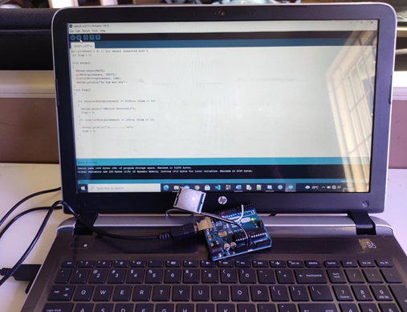

Figure 10: Connecting Arduino Board to computer to install the program

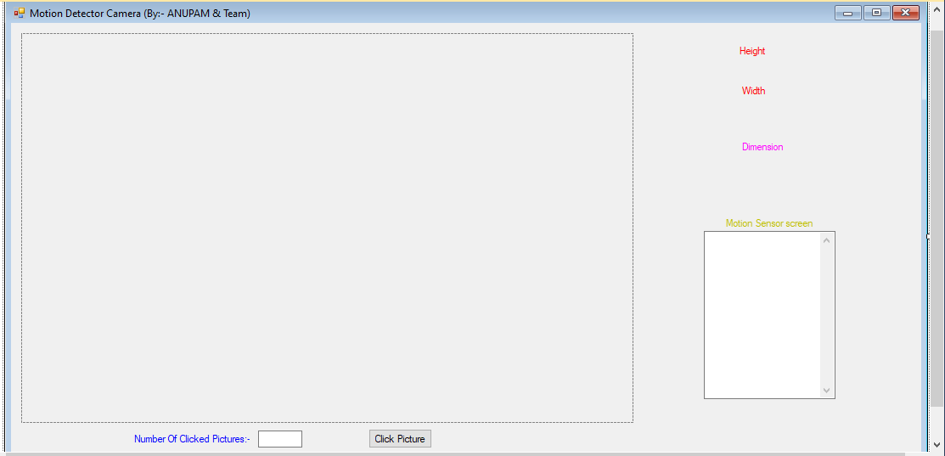

Figure 11: Display of Motion detection camera

23

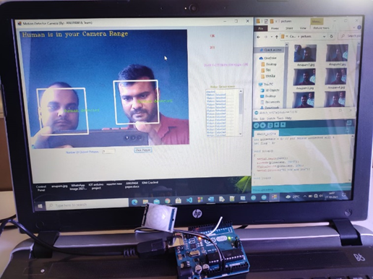

Figure 12: Camera in activation mode

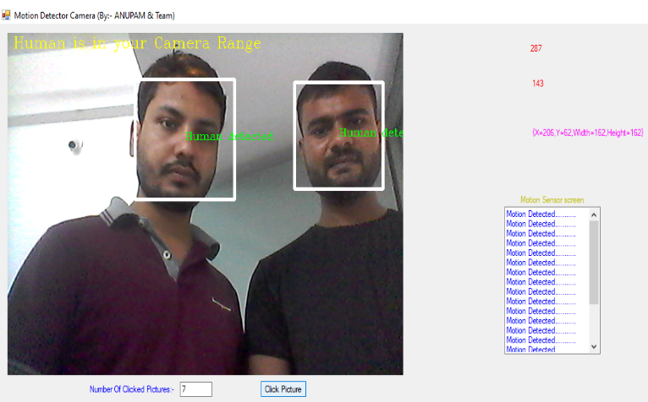

Figure 13: Human and motion is detected

24



Figure 14: After motion detected it will be clicking the photos and saved into assigned location



Figure 15: Clicked picture Saved in assigned pictures folder

25

# References

1. Ahmad, Mushtaq, et al. "Device‐centric communication in IoT: an energy efficiency perspective." *Transactions on Emerging Telecommunications Technologies* 31.2 (2020): e3750.
2. Al-Oudat, Naeem, Ahmad Aljaafreh, and Murad Alaqtash. "Iot-based home and community energy management system in Jordan." *Procedia Computer Science* 160 (2019): 142-148.
3. Al-Turjman, Fadi. "A rational data delivery framework for disaster-inspired internet of nano-things (IoNT) in practice." *Cluster Computing* 22.1 (2019): 1751-1763.
4. Al‐Turjman, Fadi, and Ilyes Baali. "Machine learning for wearable IoT‐based applications: A survey." *Transactions on Emerging Telecommunications Technologies* (2019): e3635.
5. Ashraf, Nouman, et al. "Combined data rate and energy management in harvesting enabled tactile IoT sensing devices." *IEEE Transactions on Industrial Informatics* 15.5 (2019): 3006-3015.
6. Liu, Yi, et al. "Intelligent edge computing for IoT-based energy management in smart cities." *IEEE network* 33.2 (2019): 111-117.
7. Rashid, Rozeha A., et al. "Machine learning for smart energy monitoring of home appliances using IoT." *2019 Eleventh International Conference on Ubiquitous and Future Networks (ICUFN)*. IEEE, 2019.
8. Terroso-Saenz, Fernando, et al. "An open IoT platform for the management and analysis of energy data." *Future generation computer systems* 92 (2019): 1066-1079.
9. Chaudhari, Mukesh, et al. "Motion Sensor Surveillance Cam with Data Compression Technique."

26

1. Venkatesh, C. "SMART MISBEHAVIOUR DETECTOR." *INFORMATION TECHNOLOGY IN INDUSTRY* 9.3 (2021): 84-88.
2. Shaalini, R., et al. "Human motion detection and tracking for real-time security system." *International Journal of Advanced Research in Computer Science and Software Engineering* 3.12 (2013).
3. Wang, Dongjian, et al. "Method and System for Advanced Motion Detection and Decision Mechanism for a Comb Filter in an Analog Video Decoder." U.S. Patent Application No. 12/570,541.
4. Deepika, T., and P. Srinivasa Babu. "Motion Detection In Real-Time Video Surveillance With Movement Frame Capture And Auto Record." *International Journal of Innovative Research in Science, Engineering and Technology (IJIRSET)* 3.1 (2014): 146-149.
5. Singla, Nishu. "Motion detection based on frame difference method." *International Journal of Information & Computation Technology* 4.15 (2014): 1559-1565.
6. Cheng, Hsu-Yung, et al. "Binarization method based on pixel-level dynamic thresholds for change detection in image sequences." *Journal of information science and engineering* 22.3 (2006): 545-557.
7. Aldrich, Frances K. "Smart homes: past, present and future." *Inside the smart home*. Springer, London, 2003. 17-39.
8. Mehr, Homay Danaei, and Huseyin Polat. "Human activity recognition in smart home with deep learning approach." *2019 7th International Istanbul Smart Grids and Cities Congress and Fair (ICSG)*. IEEE, 2019.
9. Jiang, Wenjun, et al. "Towards environment independent device free human activity recognition." *Proceedings of the 24th Annual International Conference on Mobile Computing and Networking*. 2018.
10. Tran, Khai N., et al. "Activity analysis in crowded environments using social cues for group discovery and human interaction modeling." *Pattern Recognition Letters* 44 (2014): 49-57.
11. Aggarwal, Jake K., and Lu Xia. "Human activity recognition from 3d data: A review." *Pattern Recognition Letters* 48 (2014): 70-80.ss.